AWS SYSOPS Project

Q1: Create an EC2 Instance (OS: Windows 2012R2 Base)

Q2: Install IIS roles

Q3: Create the image of the above setup and save the AMI for future reference

Q4: Create a new instance using the above AMI

Q5: Create a Load Balancer and attach the above instances

Q6: Access the Load Balancer URL to test the application

Step 1🡪 Create an EC2 Instance (OS: Windows 2012R2 Base)

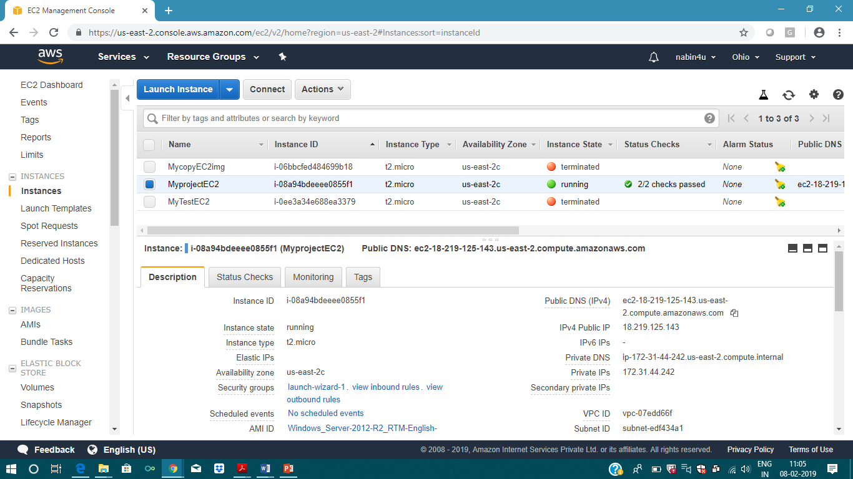

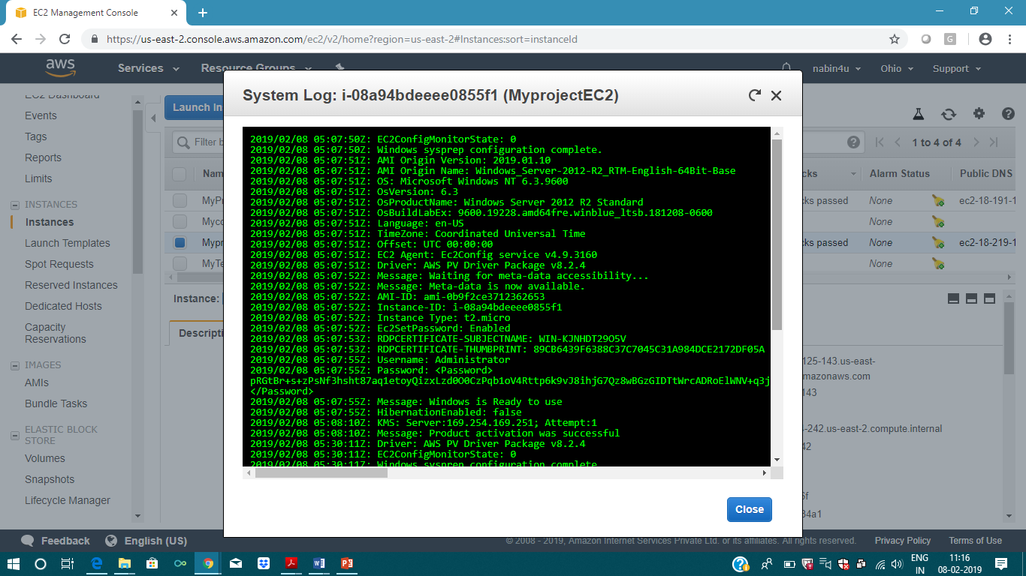

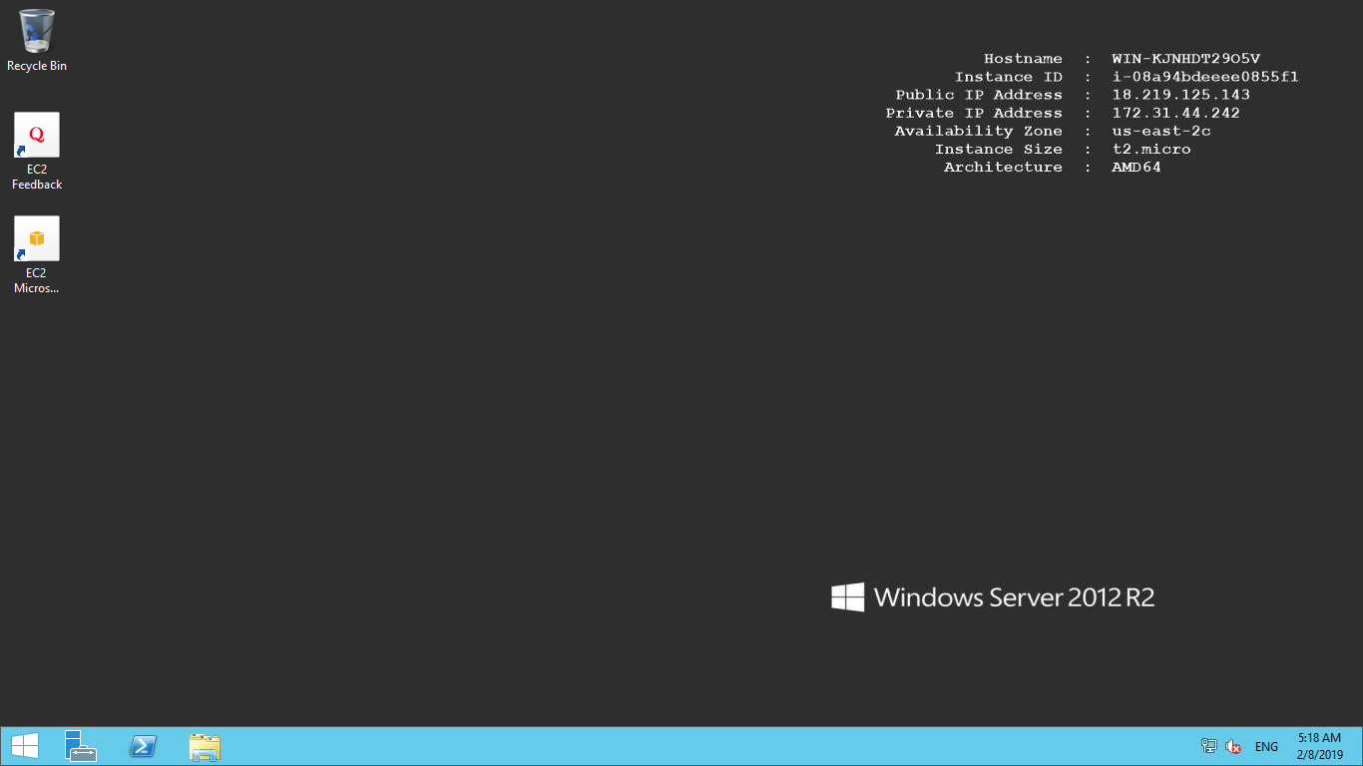

Step -2🡪 Install IIS roles

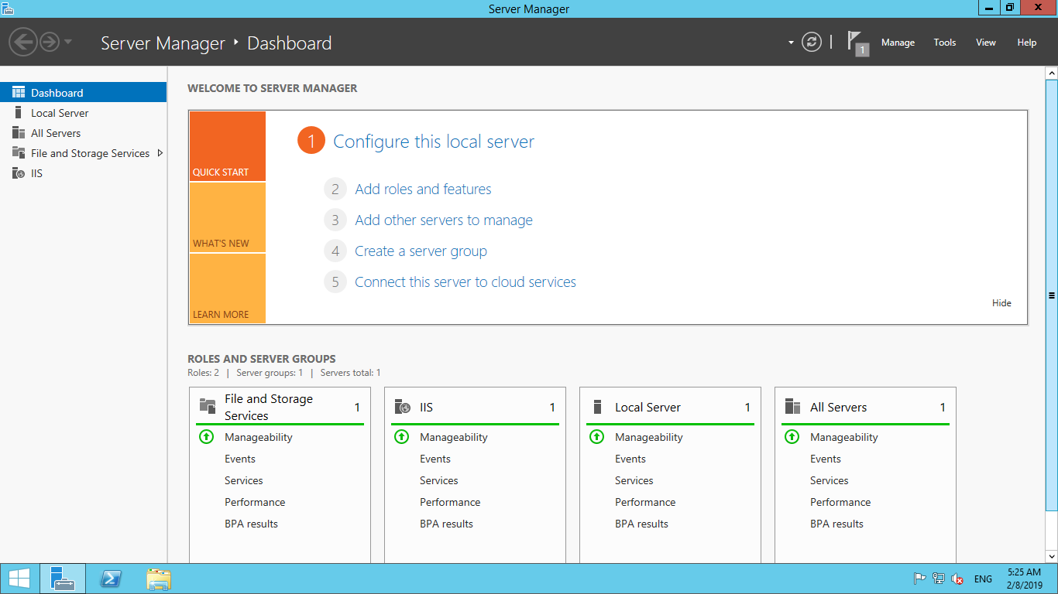

Step 3🡪Create the image of the above setup and save the AMI for future reference

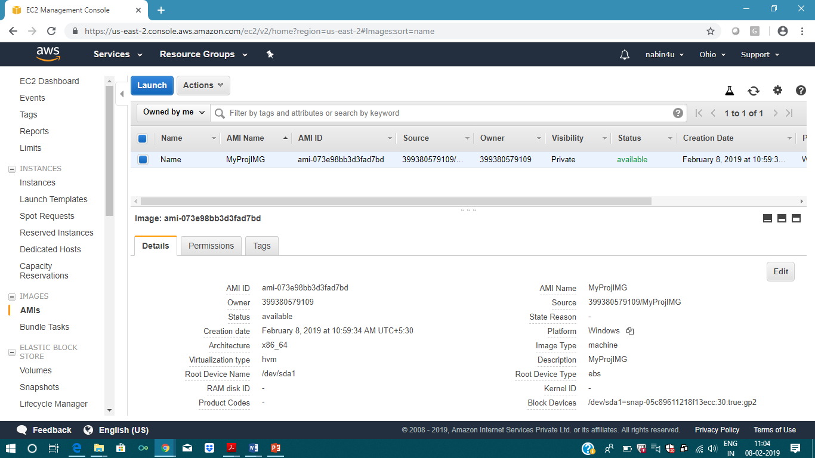

Step 4🡪 Create a new instance using the above AMI

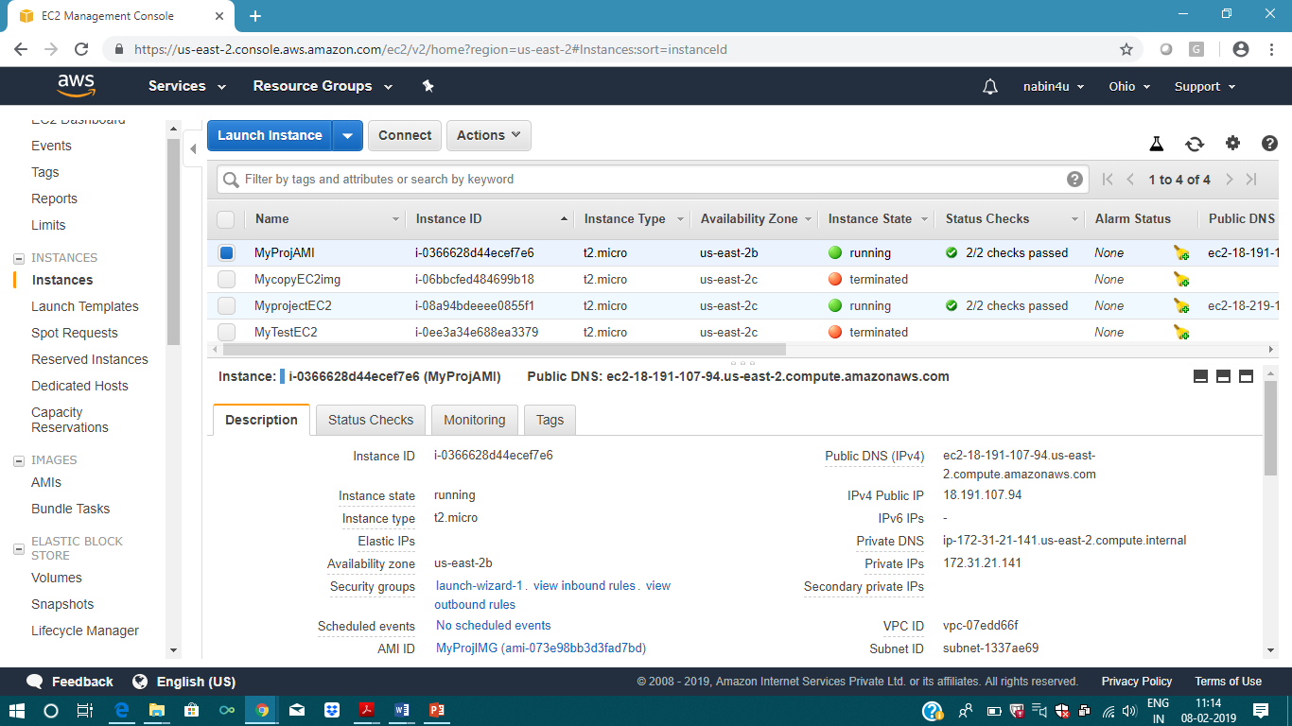

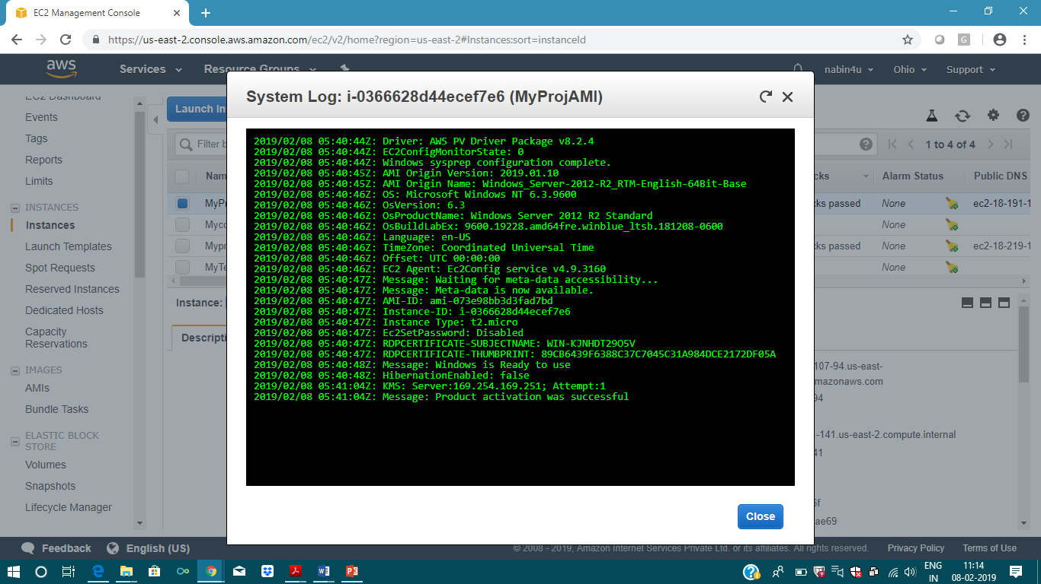

Step 6🡪 Create a Load Balancer and attach the above instances

